May 2022
Theme: Access
Purpose: To ensure that policies and practices are in place at the school and district levels to support academic fairness and inclusion for all students.
Quote: "It is not beyond our power to create a world in which all children have access to a good education." Nelson Mandela
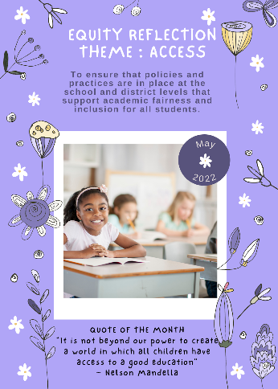
April 2022
April 2022
Theme: Barriers
Purpose: To recognize barriers that may exist within the educational setting that impacts students' ability to succeed.
Quote: "To find equality for mankind, we must first remove barriers that have divided us for so long." ~Robert M. Hensel
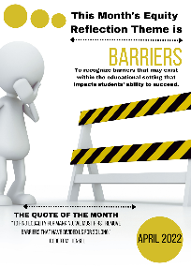
March 2022
Theme: Courageous Leadership
Purpose: To encourage leadership that empowers us to face our fears and lead even in the face of adversity.
Quote: "Courageous leadership is not fearless leadership. What makes you a leader is how you deal with your fears." ~ Andy Hargreaves
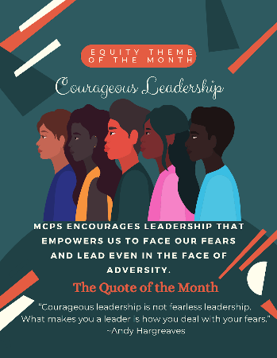
February 2022
Theme: Community
Purpose: To embrace the diversity of our community, which is our greatest strength. Quote:
“There is no power for change greater than a community discovering what it cares about.”
~Margaret Wheatley
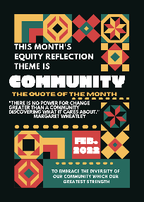
January 2022
Theme: Belonging
Purpose: To emphasize the importance of cultivating and experiencing joy even during times of difficulty and resistance.
Quote: "Joy does not happen to us. We have to choose joy and keep choosing it everyday." ~Henry J. Nouwen
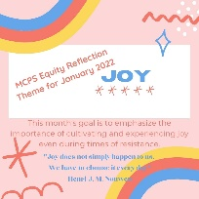
December
Theme: Belonging
Purpose: To understand how belonging is important to all human beings, and how a sense or lack of belonging can impact a student's educational journey.
Quote: "Belonging doesn't require us to change who we are' it requires us to BE who we are." ~ Brene' Brown
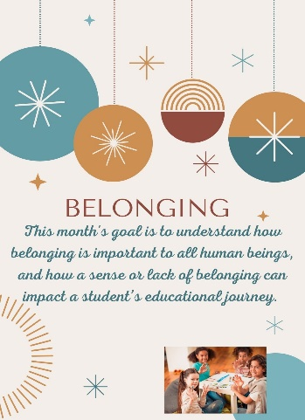
Reflection Link: Sense of Belonging
November
Theme: Culturally Responsive Teaching Practices
Purpose: To become familiar with and embrace the cultures that are represented in our schools.
Quote: "Culturally Responsive Teaching is an approach that empowers students, intellectually, socially and emotionally by using cultural referents to impart knowledge, skills, and attitudes." ~Gloria Landson-Billings
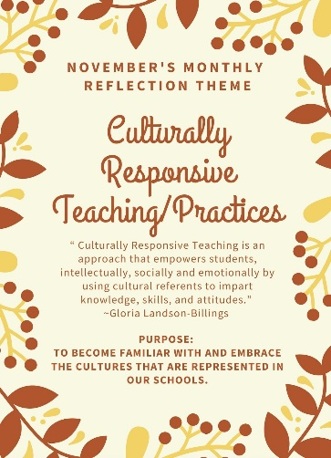
Reflection Link: Welcoming Classroom ; What is culturally responsive teaching?
October
Theme: Engagement
Purpose: To be aware of dimensions of student engagement and how it impacts their learning.
Quote: "Tell me and I forget. Teach me and I remember. Involve me and I learn." ~Benjamin Franklin
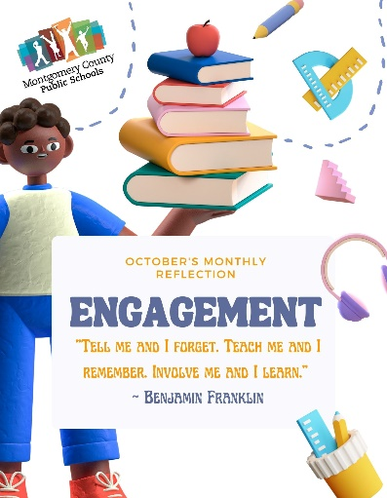
Reflection Link: Student Engagement; How parents can get involved
September
Theme: Education Equity
Purpose: To understand Education Equity as defined by the Virginia Department of Education.
Quote: "Education Equity is achieved when we eliminate the predictability of student outcomes based on race, gender, zip code, ability, socioeconomic status or languages spoken at home." ~VDOE
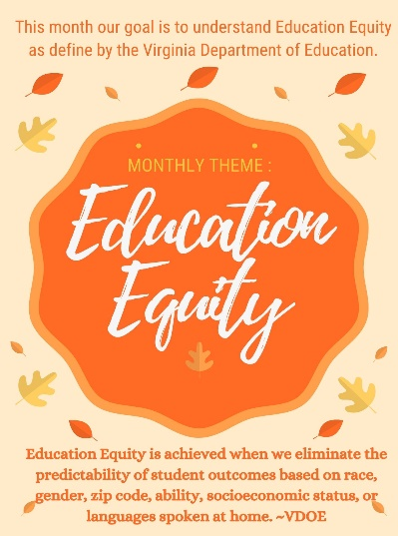
Reflection Link: Navigating Equity
August
Theme: Self-Reflection
Purpose: To acknowledge where I am in my equity journey. To identify my strengths and my challenges as I continue to learn and apply equity in my life.
Quote: "Honest self-reflection opens your mind to reprogramming, change, success, and freedom." ~Nicolee Anderson
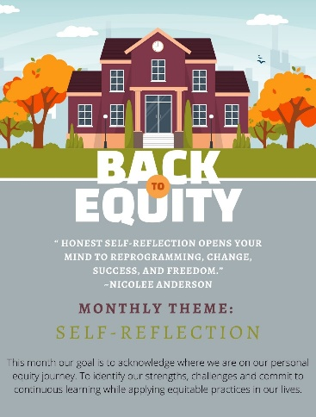
Reflection Link: Simon Sinek: How Reflection Informs Personal Growth

